Bahria University,

Karachi Campus



LAB EXPERIMENT NO.

**05**

LIST OF TASKS

|  |  |
| --- | --- |
| TASK NO | OBJECTIVE |
| 1 | Write the same program with small variation i.e. this time the program will ask for 3 integers twice and displays the result for each addition separately. |
| 2 | Write an assembly program that Multiply two number within the range of 10. |
| 3 | Write an assembly program that Divide two number within the range of 10. |
| 4 | Write an assembly program that Read and Print Hello world. |
| 5 | Write an assembly program that add two number within the range of 10. |
| 6 | Write an assembly program that subtract two number within the range of 10. |
|  |  |
|  |  |

Submitted On:

Date: 31/10/2022

Example 1: Write a program to print string.

**Source Code:**

.data

prompt: .ascii "Shoaib \n"

.text

.globl main

main:

li $v0,4

la $a0,prompt

syscall

li $v0,10

syscall

**Output:**

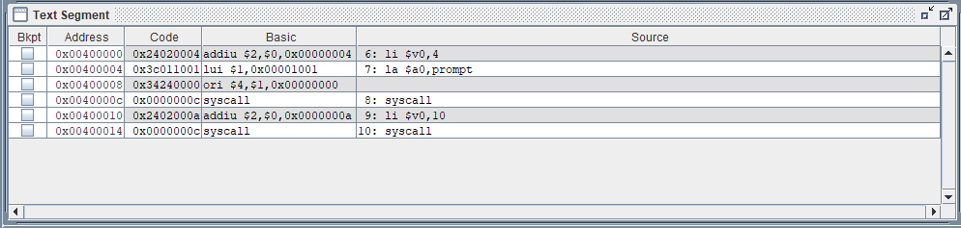

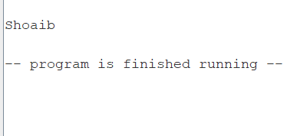

**Example No 2:** Add two Numbers and display the output with prompt

**Source Code:**

.data

prompt: .ascii "The sum of Numbers are \n"

num1: .word 10

num2: .word 15

.text

.globl main

main:

lw $t0,num1

lw $t1,num2

add $t2,$t0,$t1

li $v0,4

la $a0,prompt

syscall

move $a0,$t2

li $v0,1

syscall

li $v0,10

syscall

**Output:**

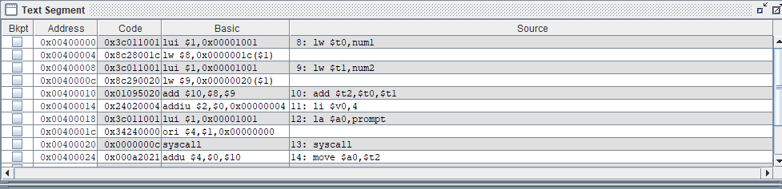

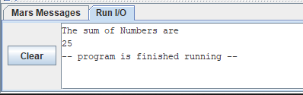

**Task No. 1:** Write the same program with small variation i.e. this time the program will ask for 3 integers twice and displays the result for each addition separately;

Output will look like as follows:

Enter 3 integers for 1st addition

2 2 2

Enter 3 integers for 2nd addition

3 3 3

The sum of 1st addition is 6

The sum of 2nd addition is 9

**Source Code:**

.data

first: .asciiz "Enter three integers for 1st Addition\n"

second: .asciiz "Enter three integers for 2nd Addition\n"

first_msg: .asciiz "The sum of 1st Addition is "

second_msg: .asciiz "The sum of 2nd Addition is "

.text

.globl main

main:

la $a0,first

li $v0,4

syscall

li $v0,5

syscall

move $t1,$v0

li $v0,5

syscall

move $t2,$v0

li $v0,5

syscall

move $t3,$v0

addu $t1,$t1,$t2

addu $t1,$t1,$t3

la $a0,first_msg

li $v0,4

syscall

move $a0,$t1

li $v0,1

syscall

la $a0,second

li $v0,4

syscall

li $v0,5

syscall

move $t4,$v0

li $v0,5

syscall

move $t5,$v0

li $v0,5

syscall

move $t6,$v0

addu $t4,$t4,$t5

addu $t4,$t4,$t6

la $a0,second_msg

li $v0,4

syscall

move $a0,$t1

li $v0,1

syscall

li $v0,10

syscall

**Output:**

**Task No. 2:** Write an assembly program that Multiply two number within the range of 10.

**Source Code:**

.data

first: .asciiz "Enter first Number \n"

second: .asciiz "Enter second Number\n"

first_msg: .asciiz "The Multiply of two Numbers are "

.text

.globl main

main:

la $a0,first

li $v0,4

syscall

li $v0,5

syscall

move $t1,$v0

la $a0,second

li $v0,4

syscall

li $v0,5

syscall

move $t2,$v0

mul $t1,$t1,$t2

la $a0,first_msg

li $v0,4

syscall

move $a0,$t1

li $v0,1

syscall

li $v0,10

syscall

**Output:**

**Task No. 3:** Write an assembly program that Divide two number within the range of 10.

**Source Code:**

.data

first: .asciiz "Enter first Number \n"

second: .asciiz "Enter second Number\n"

first_msg: .asciiz "The Division of two Numbers are "

.text

.globl main

main:

la $a0,first

li $v0,4

syscall

li $v0,5

syscall

move $t1,$v0

la $a0,second

li $v0,4

syscall

li $v0,5

syscall

move $t2,$v0

div $t1,$t1,$t2

la $a0,first_msg

li $v0,4

syscall

move $a0,$t1

li $v0,1

syscall

li $v0,10

syscall

**Output:**

**Task No. 4:** Write an assembly program that Read and Print Hello world.

**Source Code:**

.text

.globl main

main:

li $v0,4

la $a0,question

syscall

li $v0,8

la $a1,size

syscall

li $v0,4

syscall

**Output:**

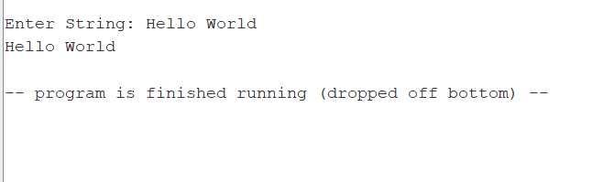

**Task No. 5:** Write an assembly program that add two number within the range of 10.

**Source Code:**

.data

first: .asciiz "Enter first Number \n"

second: .asciiz "Enter second Number\n"

first_msg: .asciiz "The Addition of two Numbers are "

.text

.globl main

main:

la $a0,first

li $v0,4

syscall

li $v0,5

syscall

move $t1,$v0

la $a0,second

li $v0,4

syscall

li $v0,5

syscall

move $t2,$v0

add $t1,$t1,$t2

la $a0,first_msg

li $v0,4

syscall

move $a0,$t1

li $v0,1

syscall

li $v0,10

syscall

**Output:**

**Task No. 6:** Write an assembly program that subtract two number within the range of 10.

**Source Code:**

.data

first: .asciiz "Enter first Number \n"

second: .asciiz "Enter second Number\n"

first_msg: .asciiz "The Addition of two Numbers are "

.text

.globl main

main:

la $a0,first

li $v0,4

syscall

li $v0,5

syscall

move $t1,$v0

la $a0,second

li $v0,4

syscall

li $v0,5

syscall

move $t2,$v0

sub $t1,$t1,$t2

la $a0,first_msg

li $v0,4

syscall

move $a0,$t1

li $v0,1

syscall

li $v0,10

syscall

**Output:**

